

2 Minute Form
Trip Name: St Helier’s to Brown’s Island
Check-in Name and Phone
Date: Branch:
Leaders
Cell Phone Number
VHF Call Sign &/or Vessel Name
Vehicle make, model, registration, colour
General Plan  Note: If plan changes, you must notify your Check-in person. | Help to protect the Hauraki Gulf’s ‘Treasure Islands’: Brown’s Island is free of animal pests - please check your kayak and gear for rats, mice, insects (including Argentine ants) and weed seeds.
Latest Time Off the Water |  |  |  |  | TMP/ AMP used²⁰ | Brown’s Island from St Heliers
Tide/ Forecast Lake Level | High  Low  High |  |  |  | Other
Communications Carried²¹ | VHF, cell phone
Communications | We will be communicating as a group on VHF Channel
Equipment Carried
Trip Report
(Use other side if more space required)

Activity |  |  | Club trip |  |  |  | Centre | Auckland |  | Location |  |  |  |  | Hauraki Gulf |  | Difficulty¹ |  |  |  |  | Beginners
Activity Description |  |  | Meet at the big concrete boat ramp in the middle of St Heliers Beach. Paddle across to Brown’s Island. Return |  |  |  |  |  |  |  | Leader qualification req.² |  |  |  | Trip Leader
Get in Location |  |  | St Helier’s |  |  |  |  |  |  |  | Chart/ Map no.⁴ |  |  |  | 532 |  | Distance |  |  |  |  | About 12km (circumnavigate)
Get out Location |  |  | St Helier’s |  |  |  |  |  |  |  | Coastguard Channel |  |  |  | 80 & 16 |  | Nowcasting |  |  |  |  | 21
Emergency get out ⁵ |  |  | Karaka Bay, Ladies Bay |  |  |  |  |  |  |  | Emergency / Coastguard Station |  |  |  | Auckland |  | Phone |  |  |  |  | *500  09 303 4303
 |  |  |  |  |  |  |  |  |  |  | Drinking Water⁶ |  | No |  |  | Toilets⁷ |  |  |  |  | Yes at St Heliers; Brown’s has nice bushes
Emergency Response |  |  | Refer Emergency Response Booklet |  |  |  |  |  |  |  |  |  |  |  |  | Parking⁸ |  |  |  |  | Yes
Specific Equipment Required⁹ |  |  | None |  |  |  |  |  |  |  | Working Communications equipment in this area¹⁰ |  | Cell phone  Sat phone |  |  |  |  |  | Mountain Radio |  |  |  | PLB  VHF
Other resources  and notes¹¹ |  |  | There are the options of landing on the beach closest to Auckland, paddling around to Crater Bay on the NE side, and circumnavigating, or not. It is worth the walk to the top – it is quite steep but only takes about 10-15 minutes and gives spectacular views of Auckland City and the Hauraki Gulf.  Recommend that you only attempt the walk to the top from Crater Bay. There are no formed tracks and it is easy to end up thigh deep in kikuyu grass which makes walking very slow and difficult.  Note that Brown’s Island is pest free – please check your boat and gear for rats, mice, Argentine ants, Rainbow skinks, soil and seeds.  The island is a popular site for shore birds including the endangered NZ dotterel and the variable oystercatcher. Look out for nest sites and stay clear.  This is a good destination for an evening or night paddle. Ensure that all boats have suitable deck light etc. |  |  |  |  |  |  |  | Weather Parameters¹² |  | Beginner: no significant surf or swell, wind under 15 knots.  Intermediate: surf or ocean swells less than 1.5 metres or wind under 25 knots.  Advanced: any condition that’s suitable for the trip’s aims.
Previous incidents¹³
Safety Management¹⁴
Hazard |  | Significant? |  |  | Management Strategy¹⁵ |  |  |  |  |  | Hazard | Significant? |  | Management Strategy¹⁵
Cold Water |  | Yes |  |  | Carry spare dry clothes and shelter |  |  |  |  |  | Deep Water | Yes |  | Correctly fit PFDs
Medical Conditions |  | Yes |  |  | - Leader has first aid qualification  - Ask customers about medical conditions |  |  |  |  |  | Bad Weather | Yes |  | Understand weather forecasts.  Have back up plans or pull out if necessary
Capsizing |  | Yes |  |  | - Correctly fit PFDs  - Skills at performing rescues. |  |  |  |  |  | Heat / Sun | Yes |  | - Protective Clothing (worn)  - Sun Screen  - Plenty of drinks  - Sunglasses
Panic |  | Yes |  |  | Ensure conditions match level  of skills |  |  |  |  |  | Obstacles | Ye s |  | Awareness of reefs, navigational hazards, nets.
Fisherman |  | Yes |  |  | There are often fishermen on the rocks at the end of St Heliers Point – stay clear. |  |  |  |  |  | Other Vessels | Yes |  | Often lots going into Tamaki River on weekend afternoons. Keep a look out.  - Understand the “rules of the sea”  - “Be seen” – Have two of the following; flag, brightly coloured kayak, brightly coloured Pfd or hat. At night: an all round white light & a powerful torch.
Nudist Beach |  | No |  |  | Nudist beach at the end of St Heliers Point – those easily offended should avert eyes. |  |  |  |  |  | Slips and falls | Yes |  | The climb to the top of Brown’s Island is short but steep  - Footwear with good grip is needed, some kayak shoes are fine, but jandals are not recommended.  - A small backpack or bag is handy to leave your hands free for safety as you carry your lunch etc to the top.
Ferry Channel |  | Yes |  |  | - There are regular ferries between Auckland City and Half Moon Bay. Keep a look out.  - The big red car ferry from Half Moon Bay to Waiheke will go across our channel when the tide is low. Low tide info is on www.sealink.co.nz  - Both ferries give a very brief “all VHF channels” notice when they are going to enter and leave the Tamaki River. |  |  |  |  |  | Low Tide at St Heliers | No |  | The tide goes out a long way – anything lower than 0.4m when you return is going to be muddy. Take trolley or strong people for carrying if you are going to be landing or launching near low tide, and take care with footing to avoid slips while carrying kayaks
Written up by: | Larraine Williams |  |  | Approved By: |  | Russell Williams |  |  | Signed: | RW |  | Date: |  | 19 Jun 2016 |  |  |  | Review in: |  | 12 months from date of approval
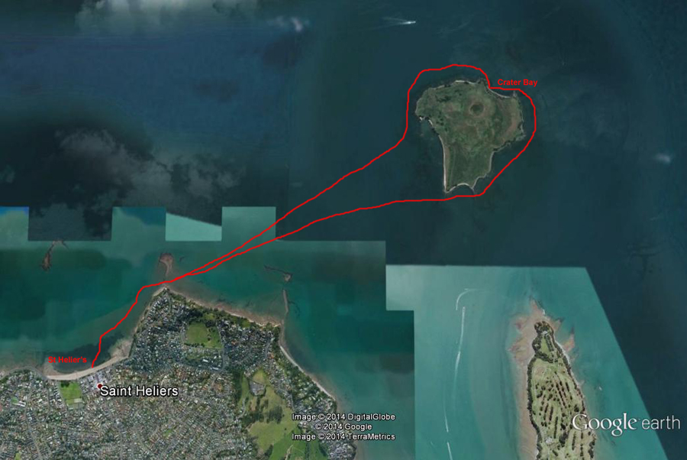

Additional Information Sheet (Optional)
Introduction (A general introduction)
Description (A description of the tour – as if you were selling the idea to someone)
Local Attractions |  | Transport/ Local Operators
 | Contact details |  | Contact details
Local Eateries
Village Co-op  8 Maheke St, St Heliers (just off the main street) | This is a tiny café which sells the best home-made ice-cream, and very nice coffee. At the end of the trip, sit on the beach and indulge – you’ve earned it.
Accommodation/ Campsite Locations |  |  | Facilities
Name |  |  | Cabins |  | Fuel
Phone |  |  | Showers |  | Power
E-mail |  |  | Toilets |  | Water Access
Website |  |  | Laundry |  | Pool
Physical Address |  |  | Water |  | Fires Allowed
Other |  |  | Supplies
Other information

